[Company name] Expense Policy

Version: 1.0
Date: 01-01-2021

Table of contents

- Policy outline
- Scope
- Proof of purchase
- Minimizing expenses
- Non-reimbursable travel expenses
- Procedure
- Business gifts
- Other expenses
- Fraud
- Disclaimer

Policy outline
This Expense Policy outlines how we reimburse employees for work-related expenses. We explain how our expense process works, which expenses will or will not be reimbursed and share guidelines for expense etiquette.

Scope
This policy applies to all employees that spend money on work-related activities or products. We’ll reimburse all reasonable business expenses, after they are approved, in part or in full, depending on their alignment with this policy.

Proof of purchase
You can only claim expenses with a valid proof of purchase. So always ask for a receipt or invoice of every single purchase. You can digitize the expenses with the [Klippa] expense app (see image below), so you don’t need to store the original receipt. Make sure that invoices always have our company name on it. Specifically ask the merchant to change this, if that is not the case. Also make sure the receipts and invoices include the product names and VAT values. This is needed to reclaim the VAT with local or international tax authorities. Receipts without VAT and product descriptions are not valid as a proof of purchase!

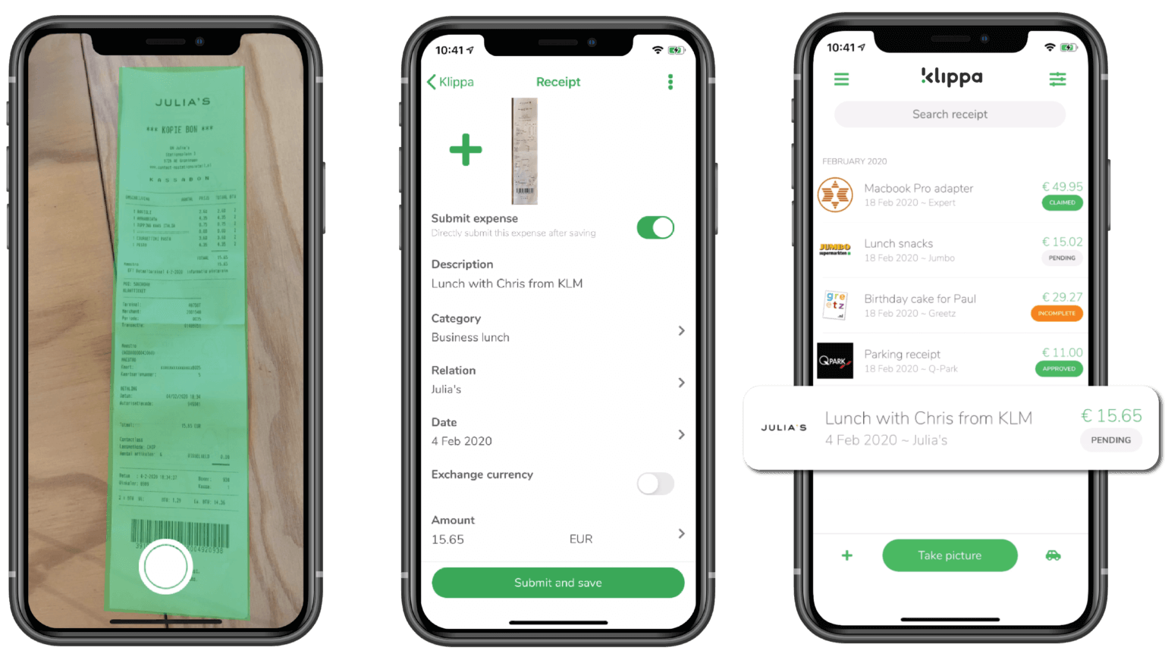

Minimizing expenses
We want to guarantee employee’s comfort while traveling, but we want to avoid unnecessary spending. Therefore we always aim for an affordable option, as long as it provides employees with sufficient comfort. We book economy class plane tickets, travel second class in trains and choose hotels and restaurants in the middle segment.

Are you in doubt? You can always contact HR before making an expense. A good general guideline would be to ask yourself if you would make the same decision if you were spending your own money. If the answer is yes, it will usually be ok.

Travel expenses include any kind of transportation or accommodation expense that employees make when going on a business trip. Some amounts are capped. In case you go over the limit, you must cover the extra cost yourself. Travel expenses include:

- Plane, train or ship tickets or fares for other means of transport.
- Local transportation during trips (taxi fares, car rental, etc.)
- Parking cost, paying toll or other car related expenses at a maximum of [enter amount] per day.
- Compensation of [enter amount] for every kilometer driven with your personal car. You can not expense fuel receipts and need to attach a Google Maps overview of the route taken and the total driven distance.
- Lodging cost for overnight stays at a maximum of [enter amount] per day.
- Main meals (breakfast, lunch and dinner) during business trips. The maximum expensable amount per day for meals is [enter amount].
- Necessary medical expenses (vaccinations, for instance).
- Necessary legal documents such as visas.

Non-reimbursable travel expenses
We won’t reimburse the following expenses:

- Expenses made by any non-employee accompanying employees on their travels
- Unauthorized service upgrades to for example first class
- Personal activities (spas, museums, sightseeing, etc.)
- Personal products (gifts, clothes, etc.)
- Lost personal property (your travel insurance will cover these costs)
- Damages you might make to the services you use or locations you visit
- Any fines, for example while driving a company vehicle or your private vehicle

This list doesn’t cover everything. When you are in doubt, please ask HR about reimbursable expenses. In general the rule is: only claim expenses made with the company’s best interest in mind. Personal expenses will not be reimbursed. We trust our employees to make decisions that are in line with our company's interest.

Procedure
When you plan to go on business trips, HR will typically book your accommodation and transportation in advance. You need to make sure you:

- Keep track of any expenses that HR hasn’t paid for (taxi fares & lunches for example). Always ask for receipts! Submit your expense claims using the [Klippa] expense tool.
- Please submit your claim/report within [enter period] after returning from your trip. It’s advised to scan your receipts straight away, so you don’t lose them and the expense process is set in motion immediately.
- If your manager approves your expenses, you will receive your reimbursement(s) within [enter period].

Business gifts
It is quite common to send gifts to clients or partners with the goal of strengthening business relationships. We reimburse these costs up to [enter amount] per client, per year, for tax reasons. If you need to go over this limit, it is required to get pre-approval from your manager or the HR department. If you do not ask for pre-approval, you will have to cover the additional cost personally.

Other expenses
We want to provide employees with all things necessary to perform their jobs well. These things pertain to employees and their relationship with business contacts. Think of expenses such as:

- things you need to work from home
- a business phone
- a company laptop
- software tools used to communicate with clients or work on projects
- professional dinners with clients or colleagues

These expenses may be capped and HR should pre-approve them. In case you go over the limit, you must cover the extra costs yourself.

We will not reimburse the following expenses:

- Unauthorized business trips or unauthorized meetings with clients or partners
- Non-business related courses
- Personal trips or purchases

This list is not exhaustive. Please ask HR about reimbursable expenses when you are in doubt, before you submit a claim.

Fraud
At [company name] we believe in trusting our employees. Therefore we don’t pre-authorize most expenses and expect you to make the right decisions when making expenses. We do perform sample tests yearly to check for fraud. We consider any false expenses, double expenses and excessive expenses as fraudulent. In cases of consistently false or exaggerated claims, we may take disciplinary action.

-----

Disclaimer
This policy template is a template, and should be tailored to each organization. It may not take into account local laws and it is not a legal document. Klippa is not liable for any issues that may arise from using this policy handbook.

-----

